Great Fall

In class today, Mr. Smith did a demonstration to show us how much easier pulleys can make things. He attached a fixed pulley to the ceiling, attached a moveable pulley to the fixed one, and put a rope through both of them twice. He then tied our feet together, attached a hook on the end of the moveable pulley to the rope on our feet, and had us haul ourselves up the rope. It was really easy! He then let us swing from side to side, and gave us two choices about how to come down: slowly lowered down, or the great fall where he would measure out a certain amount of rope, hold on to the end of where he measured, and let go of the rope. He would stop you about a foot from the floor.

Things I learned:
- Friction is resistance.
- The less friction there is, the easier everything is.
- For example, if the ropes were rubbing together, then it would be harder to pull yourself up.
- Friction decreases mechanical advantage.
- It was surprisingly easy to pull yourself up.
- The great fall was really fun!
- This hurt your ankles.
- Swinging from side to side on the end of a rope hanging from the ceiling is really fun!
- Everyone's faces turned red when they were hanging upside down.
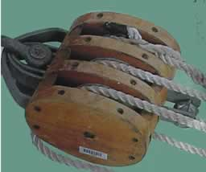
- It was the strangest thing I've ever seen in a classroom.

